INTEGRATION ASSESSMENT
Insight Summary to Patient Hub Dashboard
Scope: current-state data flows, integration alignment, and technical considerations.
1. Current Insight Summary Flow
- The current Insight Summary uses synthetic patient-therapy data as its source.
- Day-level summary data is organized in JSON format.
- Existing session values, including AHI and usage duration, are used to derive additional values from the available parameters.
- The pre-computed values are supplied to the LLM as context for generation of the Patient Summary.
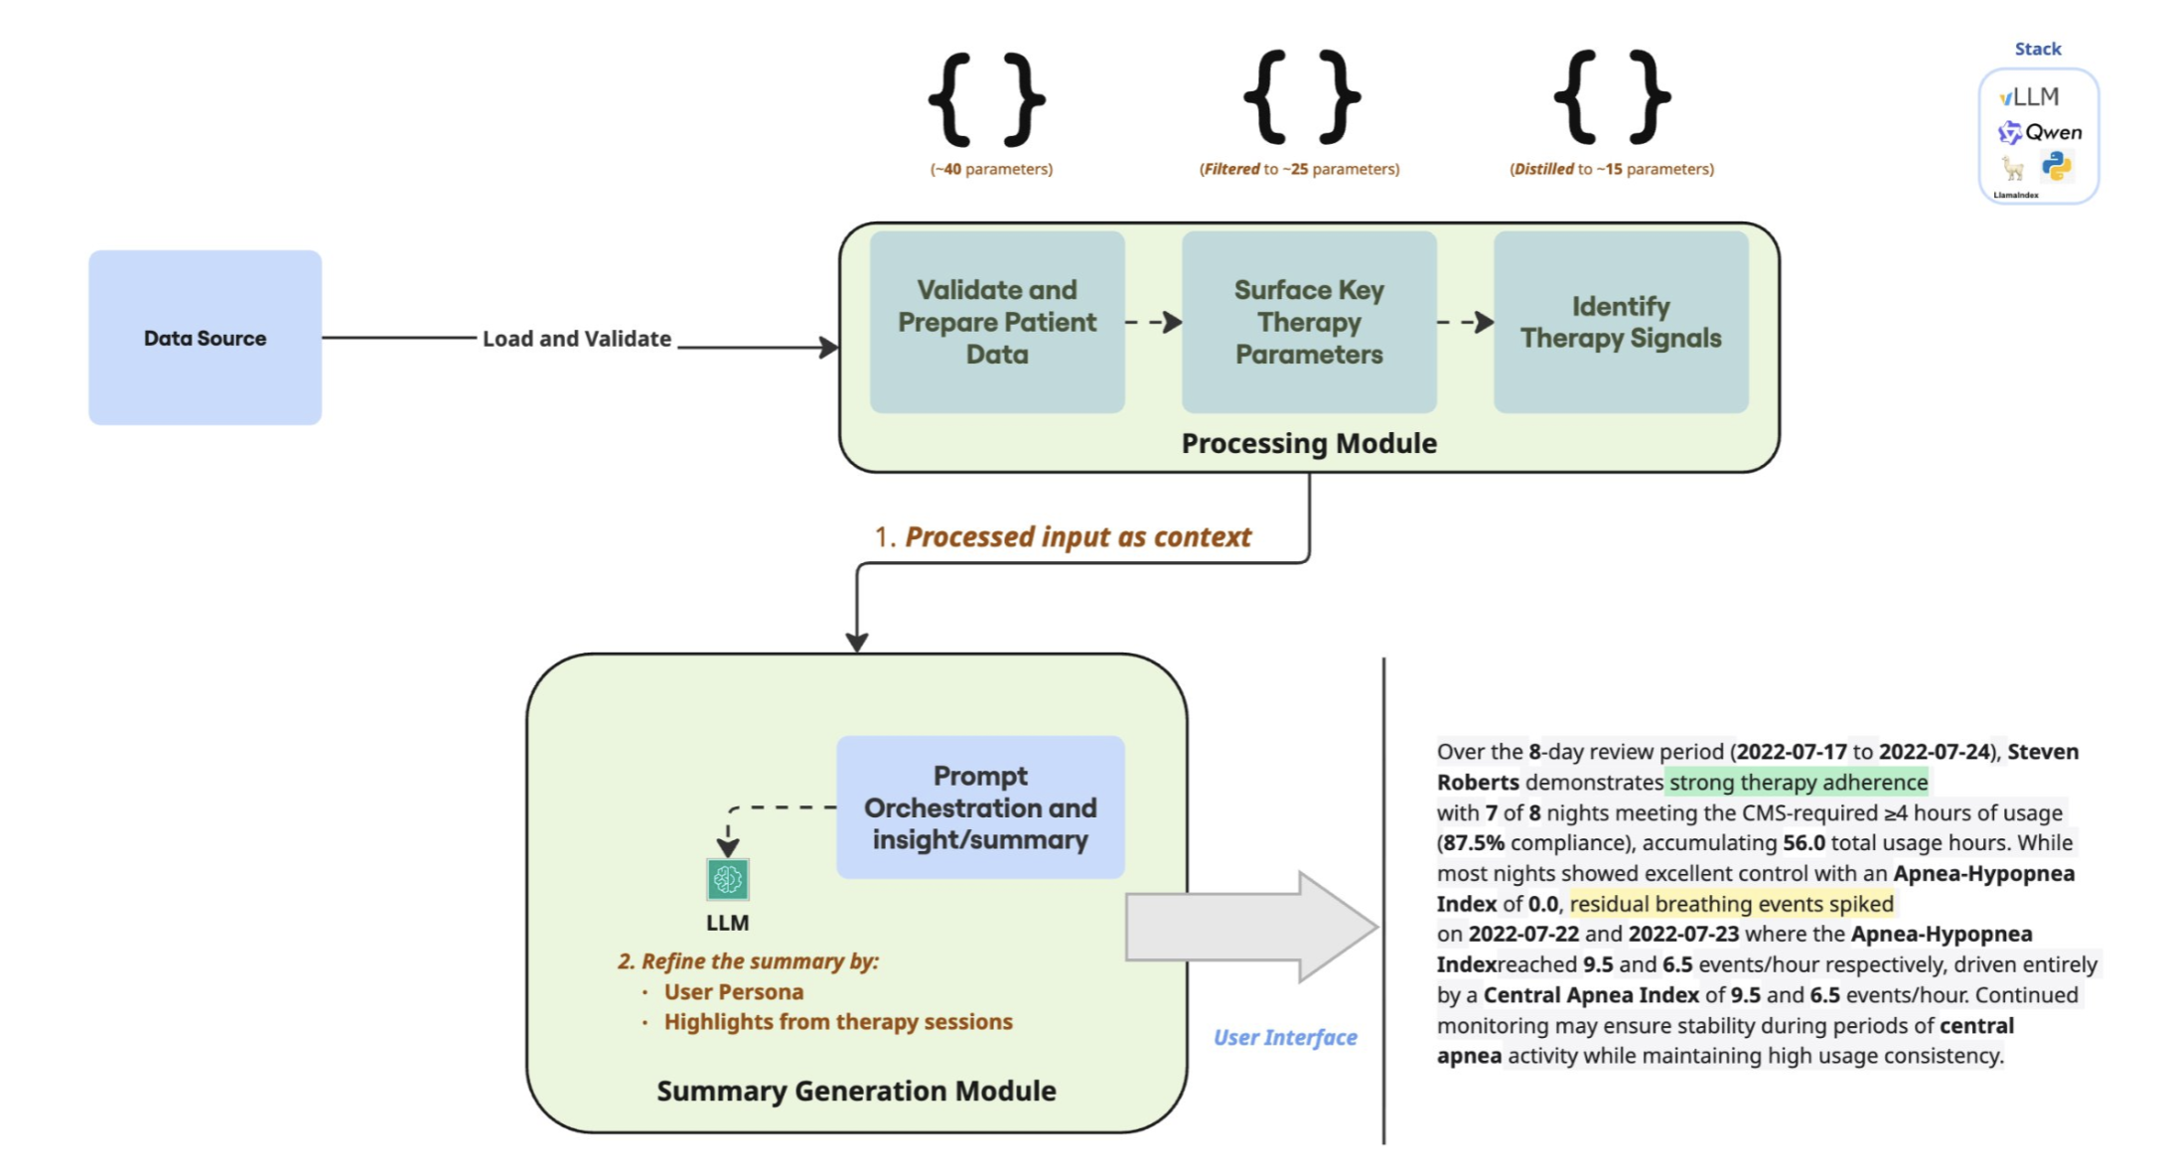

2. Current Patient Hub Flow
- Patient therapy and ventilator data from modem and SD-card sources is aggregated through the aggregation service and stored in DocDB.
- DocDB (an Amazon database) stores day-level summary data in JSON format.
- DSD parameters are transformed from JSON into structured Data Mart tables. This data is used to calculate required values through microservices and to populate the schema tables required for Patient Hub fields.
- Data Mart tables are created according to the data required for the Patient Hub Dashboard.
- The Data Mart is updated whenever new source data is received.
- Cumulative calculated data for predefined periods is computed and stored in PostgreSQL tables.
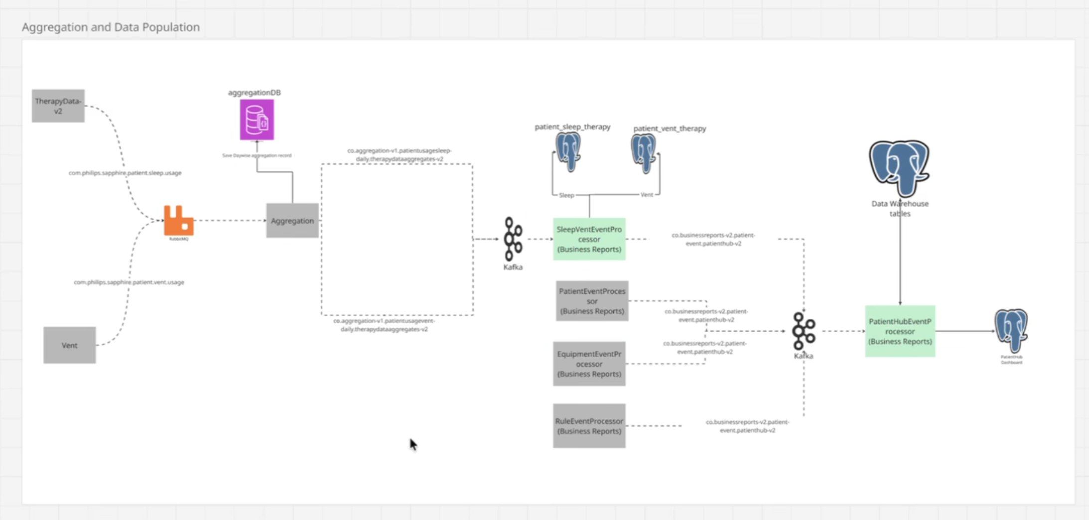

3. Current-State Comparison
Comparison of the current Insight Summary implementation and the required Patient Hub adaptation.
SL. | Details | Present State | Need to Adapt
1 | Raw Data Source | Synthetic Patient Therapy Data | Patient Therapy and Vent Data from Modems/SD Cards
2 | Raw Data Representation | Restructured list of arrays (patient ID) | Combined day-wise summary data (DSD) in DocDB
3 | Input Data Source | Synthetic Data | DocDB for combined session data; PostgreSQL for aggregated dashboard-compatible data
4 | Computations | Existing parameters (AHI, usage duration, etc.) plus derived computations (average usage, mask-fit %, etc.) in Insight Summary code | Available pre-computed values on a microservice, reusable through an API
5 | Past Data Availability | No threshold set | Maximum two years of historical data
4. Integration Considerations
Integration of the patient-therapy data summary feature with Care Orchestrator requires the following technical decisions and validation activities.
- Define the scope for Sleep and Vent data: determine whether both data types must be supported, whether they are unique, and whether the feature should accommodate one or both.
- DocDB contains Sleep and Vent session data, with the `_vent` parameter distinguishing aggregated ventilator data from Sleep data. This JSON-based representation is consistent with the current Insight Summary flow.
- The current Insight Summary prompt uses computed values to generate summaries for DME and Clinician personas. If Vent data is included, the computations and prompt must be redesigned to incorporate the relevant ventilator calculations.
- PostgreSQL contains general computed values, including AHI, Avg_Usage, and leak percentage, which can be reused through microservice functions. However, derived computations used for the Clinician-persona summary are not currently available in PostgreSQL.
- Existing computations can be reused without change, with additional computations implemented as extensions. Alternatively, the additional computations can be maintained separately outside the AI layer.
- Data-access contract details and API specifications require verification.

